Tag Jousts

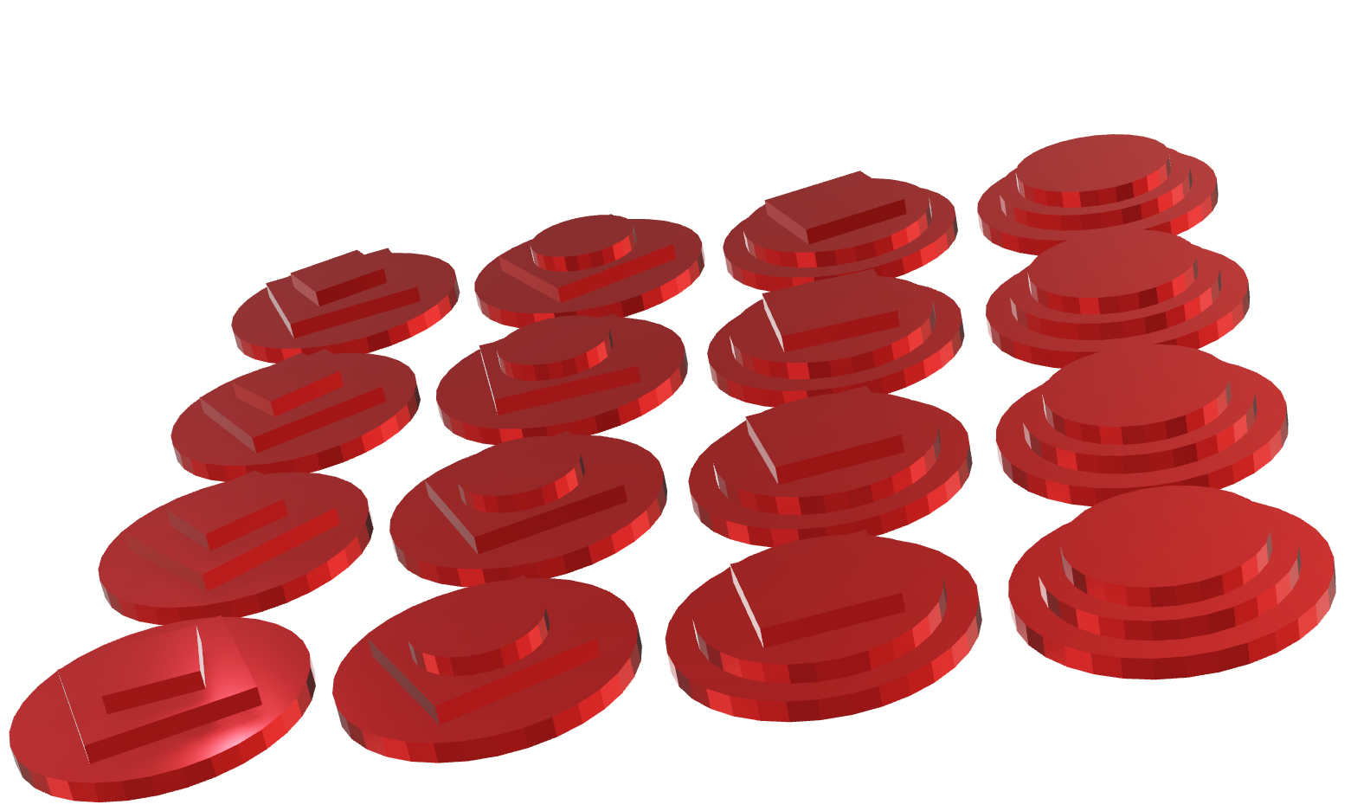

Welcome to Tag Jousts. A game of skill, luck and bluffing.

Each player starts with a set of 16 tags of one colour. A tag has two shapes on top and two on the bottom.

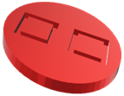

This tag is called "Big Square". It has two squares on top and two on the bottom. It is one of the most powerful tags in the game, with a score of four squares.

The game is played over 16 rounds. Players take it in turns to challenge each other in a "tag joust". At the start of a joust the attacking player throws their die to decide what will be scoring for that turn. If the die shows a square or circle that will be the scoring for the round.

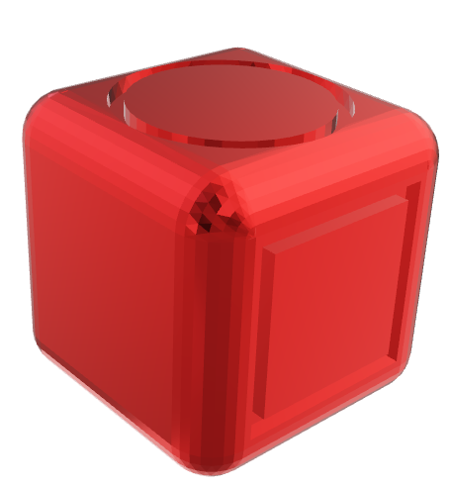If the die displays a blank face the attacker can decide what will be scoring and says either "squares" or "circles". All the players then pick a tag that will take part in the joust.

Once the tags have been chosen the players reveal the underside of their tags and score them by counting the total number of the chosen shape on their tag. The player with the highest score wins the joust. The winning player captures their opponent's tags and discards their attacking tag.

If the top score in the joust is tied all the tags in the joust are discarded. Play continues until each player has run out of tags. The winner is the player who captures the most tags in jousts.

www.tagjousts.xyz